Chart 2a
Symmetry of Scripture

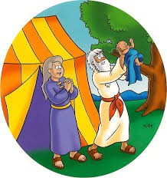
Genesis

S I N

Creation Entrance of Sin Worldwide Judgment Calling His People
(first 2 chapters) (Satan defiles) (earth destroyed by water) to Holiness

Revelation

Calling His People Worldwide Judgment End of Sin New Creation
to Holiness (earth destroyed by fire) (Satan defeated) (last 2 chapters)

