DISPERSEMENT of NATIONS
after the Flood
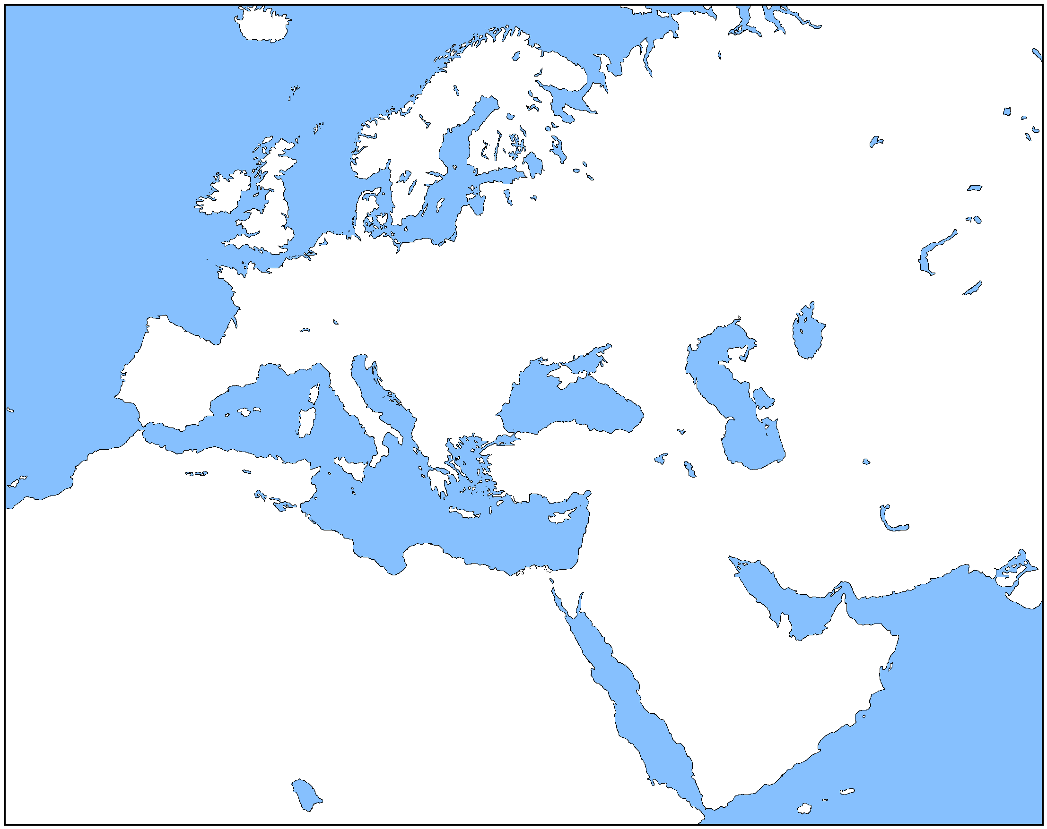
Mediterranean Sea
Black Sea
Caspian Sea
Persian Gulf
Red Sea
Arabian Sea
tiras
aram
magog
gomer
madai
javan
meshech
misraim
(egypt)
cush
put
canaan
arpachshad
lud
asshur
elam
Sahara Desert
Plain of
Shinar
Asia Minor

Mount
Ararat
tubal

- On the map above, circle the descendants of Shem in GREEN. Circle the descendants of Ham in ORANGE. Circle the descendants of Japheth in PURPLE.

- Look at the regions where Noah’s sons’ descendants are grouped on the map. Write the name of the region settled by each son’s descendants on the blank next to his name. Choose from the three regions listed in the box.
Regions:
African / Canaanite
Indo-European
Middle-Eastern / Persian
Shem
Ham
Japheth
The above map shows where Noah’s sons and their families settled in the years after the great Flood. On the map draw a PURPLE circle around the descendants of Shem. Draw an ORANGE circle around the descendants of Ham. Draw a GREEN circle around the descendants of Japheth.

