**NEWLY DISCOVERED –**

**THE FIRST RIVER OF EDEN!**

John D. Keyser

*While most people worry little about pebbles unless they are in their shoes, to geologists pebbles provide important, easily attained clues to an area's geologic composition and history. The pebbles of Kuwait offered Boston University scientist Farouk El-Baz his first humble clue to detecting a mighty river that once flowed across the now-desiccated Arabian Peninsula. Examining photos of the region taken by earth-orbiting satellites, El-Baz came to the startling conclusion that he had discovered one of the rivers of Eden -- the fabled Pishon River of Genesis 2 -- long thought to have been lost to mankind as a result of the destructive action of Noah's flood and the eroding winds of a vastly altered weather system. This article relates the fascinating details!*

In Genesis 2:10-14 we read: "Now a river went out of Eden to water the garden, and from there it parted and became four riverheads. The name of the first is PISHON; it is the one which encompasses the whole land of HAVILAH, where there is gold. And the gold of that land is good. Bdellium and the onyx stone are there. The name of the second river is Gihon; it is the one which encompasses the whole land of Cush. The name of the third river is Tigris; it is the one which goes toward the east of Assyria. The fourth river is the Euphrates."

While two of the four rivers mentioned in this passage are recognisable today and flow in the same general location as they did before the Flood, the other two have apparently disappeared from the face of the earth. Great changes occurred in the topography of the earth during the Noachian flood and also at other times in the earth's history since; so it is not that remarkable that some of the pre-Flood geographical features changed or disappeared altogether. As an example of this, scientists have found evidence of floods in Mesopotamia, deep lakes in Africa, grasslands and lakes in Arabia and heavy forest cover along the eastern Mediterranean coast. This provides testimony that a lengthy wet period once enveloped the ancient Near East. In an attempt to correctly locate and identify the Pishon and the Gihon rivers, we need to closely evaluate Genesis chapter 2. *excerpt from page 1 of Keyser’s article*

**An Amazing Discovery!**

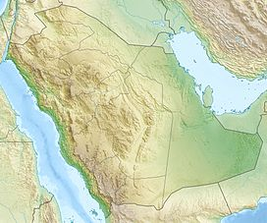

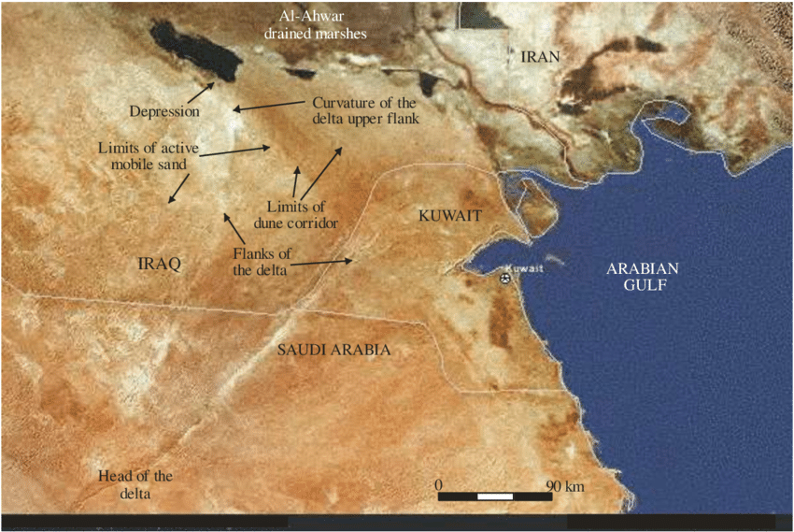Boston University scientist Farouk El-Baz had long wondered about the pebbles of granite and basalt that are abundant throughout Kuwait. The problem was that these pebbles are not indigenous to the area. The nearest source for these rocks lies in the **Hijaz Mountains** -- 650 miles to the west in Saudi Arabia!

**Kuwait**

**Hijaz Mountains**

How did the pebbles reach Kuwait? Intrigued by this puzzle, El-Baz examined photos of the region taken by satellites orbiting the earth, and to his amazement easily detected a **dried riverbed** (known today as Wadi Al-Batin) cutting through the limestone of north-central Saudi Arabia. He noticed that the riverbed petered out as it reached the sand dunes of central Saudi Arabia.

The *Biblical Archaeology Review* (July/August 1996) relates that "when he extended the line of the river across the sand dunes...EI-Baz noticed that the patterns of the desert's sand dunes 'changed precisely when they crossed this line. To the right (southeast), the dunes appear pockmarked, to the left (northeast) they are striated. Sand patterns like these are created by the circulation of the air in the desert, which in turn is influenced by the topography. Thus, El-Baz realised that something beneath the sand was the source of the variations in the sand. He determined that the river ran underground here, along a fault line" (p. 55).

For a long period of time after the recreation of Genesis 1, the river (in places 3 miles wide) dragged granite and basalt from the Hijaz mountains and dumped the pebbles along its fan-shaped delta, which covered two-thirds of modern Kuwait and part of southern Iraq.

Now the interesting thing is that this ancient river (which gradually dried up sometime after 3,500-2000 B.C.) fulfills all the requirements for one of the rivers of Eden! Notice what Genesis 2:11-12 says: "The name of the first [river] is Pishon; it is the one which ENCOMPASSES THE WHOLE LAND OF HAVILAH, where there is gold. And the gold of that land is good. Bdellium [fragrant resins] and the onyx stone are there" (NKJV).

**The Land of Havilah**

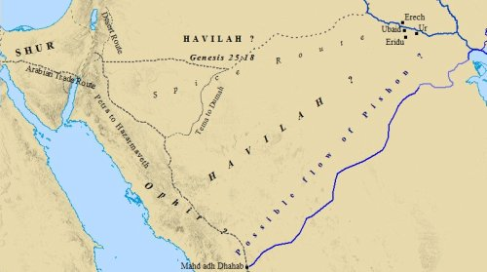An important key to determine where the river Pishon ran is the phrase "the gold of that land is good." There is only one place in the area that has such a deposit -- the site of Mahd edh-Dhahab, the famous "Cradle of Gold." Located about 125 miles south of Medina in Saudi Arabia, huge fissures on the hillside are the remnants of ancient mining that took place as early as 1000 B.C. Adds the Biblical Archaeology Review, "Rediscovered in 1932 by American mining engineer Karl Twitchell, the mine currently produces more than

**probable route of the former Pishon River**

5 tons of gold a year."

Another clue in Genesis 2:11-12 is the phrase "Bdellium and the onyx stone are there." The Arabian peninsula is *rich* with bdellium and precious stones. In the Bible dictionary *Insight On the Scriptures* we find the following: "It [bdellium gum] is obtained from a tree found in NW Africa and Arabia..." (pg. 264). Summing all this up, the dictionary goes on to say: "The description of its [Havilah's] resources is considered by some to be typically Arabian, and it is associated by some with a region in Arabia. On the basis of the Biblical reference to 'the entire land of Havilah,' J. Simons suggests that the term 'Havilah' may take in the ENTIRE ARABIAN PENINSULA ..."

- - - - - - - - - - - - - -

With the location of Havilah clearly delineated by the scriptural references and extra Biblical sources, there can be no doubt that the ancient river bed discovered by Farouk El-Baz from the satellite photographs is none other than that once used by the waters of the River Pishon that flowed through the Garden of Eden to the Persian Gulf. *excerpts from pages 5-6 of Keyser’s article*