Lesson 11
29-30 November 2021
Genesis 29-30
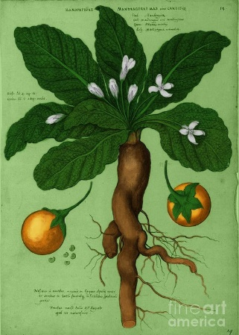
Another Perspective:
Superstitions – There are a couple of superstitious beliefs mentioned in today’s portion of Genesis. One involves the mandrake plant. Mandrakes are an odd-looking plant, with roots that intertwine and look rather like legs. They produce an orange-yellow fruit, about the size of a large plum, that are filled with a soft pulp. It was believed that these plants promoted fertility.

There is a similar superstition in Bangladesh: many village ladies believe that if a pregnant woman eats a double banana, she will have twins!
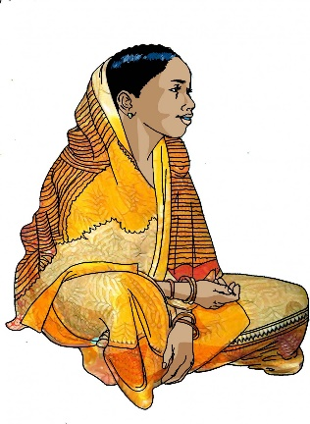

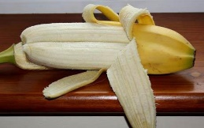

Bible Study Fellowship’s Perspective: The following comment was taken from Lesson 19 of the BSF course on Genesis.
- This comment is in relation to Laban marrying Leah to Jacob instead of Rachel: “The morning light revealed the true identity of the disguised Leah. Jacob, the deceiver, had been deceived! The comparison of Laban’s sin to Jacob’s sin cannot be avoided. Jacob, at his mother’s doing, disguised himself as his brother to deceive his father. Now Leah, at her father’s doing, disguised herself as her sister to deceive Jacob.” pg 3

