Lesson 8
8-9 November 2021
Genesis 25-26
Another Perspective:
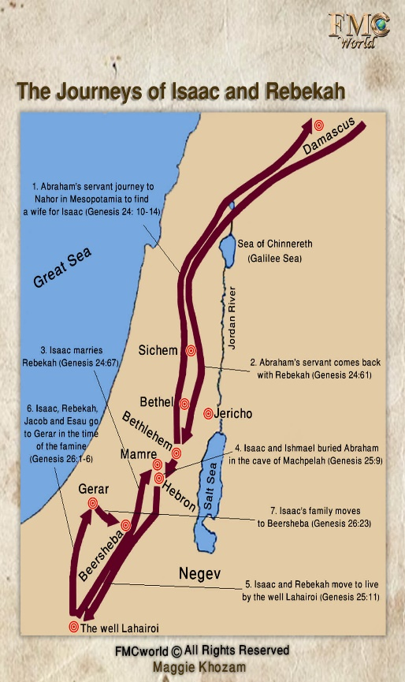
Progressive Revelation of God’s Promise – At the beginning of Genesis 26, we read that the Lord appeared to Isaac and reiterated the promises that He had made to Abraham concerning his offspring and the land. But God also added a statement that, though implied, had not been explicitly stated previously. He told Isaac, “Stay in this land as a foreigner, and I will be with you and bless you.” (Genesis 26:3) The promise of God’s presence is an important one that He repeated over and over again as He chose leaders for His people: to Moses (Exodus 3:12), to Joshua (Joshua 1:5), and others. And what did Jesus tell His disciples as He commissioned them? “Remember, I am with you always, to the end of the age.” (Matthew 28:20) The apostle Paul wrote to Timothy from prison and gave this testimony, “At my first defense, no one stood by me, but everyone deserted me…But the Lord stood with me and strengthened me…So I was rescued from the lion’s mouth.”

Map of Isaac’s Travels – Once again it is helpful to visualize where Isaac traveled as an adult. As you look on the map, you can see that he spent his entire adult life in a fairly localized region between Beer Lehairoi at the very bottom of the map (recall that Hagar had given this well its name: “The Well of the God Who Sees”) and Mamre, toward the middle of the map, where he and Ishmael buried their father Abraham.

Genealogy Chart for Abraham’s Descendants – I came across this chart this week and thought it was both useful and timely. So I’ve made copies for all of you to help you keep track of who’s who on the family tree as we continue on through the book of Genesis!

~~~~~~~~~~~~~~~~~~~~~~~~~~~~~~~~~~~~~~~~~~~~~~~~~~~~~~~
Bible Study Fellowship’s Perspective: The following comments were taken from Lesson 16 of the BSF course on Genesis.
- Notes on the Death of Abraham – The common phrase “breathed his last” first appears here in connection with the death of Abraham. It is used throughout the Bible to mean death. Another common phrase, “gathered to his people”, refers to Abraham’s reunion with Sarah and believers in God in the unseen realm. pg 1
- Ishmael and His Descendants – Ishmael’s account in Genesis 25:12-18 offers important details:
  - His mother is identified as Sarah’s slave, Hagar the Egyptian.
  - He fathered 12 tribal rulers over specific lands—just as God promised Hagar and Abraham.
  - He lived a long life—137 years—when “he breathed his last” and was “gathered to his people.”
  - His people lived in a different place than Isaac’s family.
  - Hostility and tribal infighting characterized his people and proved God’s prophecy. pg 2
- God’s Prophetic Answer to Rebekah’s Question – Like most predictive prophecies, the full meaning only becomes clear later in history. The four clauses in God’s message are now clearly understood.
  - “Two nations are in your womb” – Rebekah was the mother of twins, ancestors of two nations, Edom and Israel.
  - “Two peoples from within you will be separated” – The radically different nations were parted forever.
  - “One people will be stronger than the other” – God sovereignly elected Israel to have greater power than Edom.
  - “The older will serve the younger” – God reversed the custom that gave the firstborn inheritance of the birthright. pg 3
- Jacob’s Strategy To Gain the Birthright – Jacob was not wrong to desire the birthright God promised…Nevertheless, Jacob’s scheme and purchase of the birthright revealed failure to trust God’s way and timing. There is no record that Jacob sought God’s will. Nor did he practice God’s love, generosity or grace to achieve his goal. Jacob relied on his ingenuity to selfishly capitalize on his brother’s weakness. Jacob possibly chose a time when he knew Esau would return tired and hungry…(He) seemed prepared to pounce and demanded Esau swear to sell his birthright in exchange for the stew. Jacob and Esau were extremely different, but in this moment, they BOTH wanted what they wanted immediately, regardless of the cost or potential consequences. pg 4

- Music Video: LeAnn Carr texted me about this YouTube video that fits in beautifully with our study of Genesis. It is “The God Who Sees” by Kathie Lee Gifford and Nicole C. Mullen. So I thought we would end our session today with this since we won’t be watching the Jen Wilkin video yet.

