Back to the Basics
God of Covenant
Lesson 13 Assignment
Due 3-4 January 2022
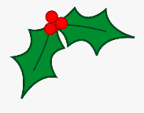
Have a Blessed Christmas!

Old Testament Books of the Bible: Genesis - Daniel
Review all the books we have memorized thus far.
- Be able to recite all the books in order from Genesis to Daniel.
- We will choose random books from the basket and give the description for the ones we draw.

God of Covenant Workbook
- Reading Assignments
  - Read the introduction to Week 7 on page 107.
  - Read Genesis 34-36 from start to finish.
- Answer the Questions
  - Week 7, Day 1 – Do summaries for all three chapters on page 108.
  - Answer all the questions for Days 1 and 2 on pages 108-112.

