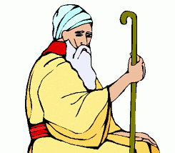
Jacob
Joseph
SCHEDULE of LESSONS
January 17 – April 5 2022
God of Covenant
Weeks 7-10

# | Date | Names in Order | Description of Book | God of Covenant book
14 | January 17, 18 | REVIEW | REVIEW | Week 7, Days 1-2
15 | January 24, 25 | MINOR PROPHETS | Hosea | Week 7, Days 3-5
16 | Jan 31 - Feb 1 |  | Joel, Amos | Trouble at Shechem, VIDEO
17 | February 7, 8 |  | Obadiah | Week 8, Days 1-3
18 | February 14, 15 |  | Jonah | Week 8, Days 4-5
19 | February 21, 22 |  | Micah | Joseph in Egypt, VIDEO
20 | Feb 28 - Mar 1 |  | Nahum | Week 9, Days 1-3
21 | March 7, 8 |  | Habakkuk | Week 9, Days 4-5
22 | March 14, 15 |  | Zephaniah | Joseph over Egypt, VIDEO
23 | March 21, 22 |  | Haggai | Week 10, Days 1-3
24 | March 28, 29 |  | Zechariah | Week 10, Days 4-5
25 | April 4, 5 |  | Malachi | Deaths of Jacob & Joseph, VIDEO

We will start a new series in April. It will run for 9 weeks.

