Time Line for Kings Cyrus and Darius of Persia

539-530 BC 521-486 BC
King Cyrus King Darius
ruled Persia ruled Persia

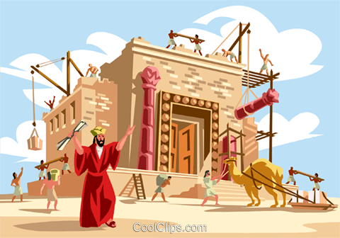

586 539 538 536 530 520 516
Babylon Persia temple work on temple
conquers conquers work temple is is
Judah Babylon begun stopped completed

decree of Cyrus decree of Darius
allows exiles to return allows work on temple to resume
~~~~~
Haggai & Zechariah
prophesy
to the people

