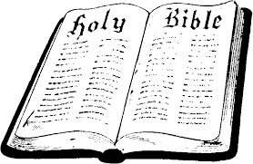
In Class Worksheet
Session 1

NEW TESTAMENT SURVEY – During Jesus’ lifetime on earth, He “announced the imminent arrival of the kingdom of God, which was another way of saying that the saving promises found in the Old Testament were about to be realized. The kingdom of God, however, came in a most unexpected way. The kingdom did not come with apocalyptic power but in a small and almost imperceptible form…It was as undetectable as leaven mixed into flour, but the leaven would eventually transform the entire batch of dough…In other words, the kingdom was already present in Jesus and His ministry, but it was not yet present in its entirety. It was ‘already—but not yet’…There would be an interval between God’s beginning to fulfill His promises in Jesus (the kingdom inaugurated) and the final realization of his promises (the kingdom consummated). The already-but-not-yet theme dominates the entire New Testament and [is] key to grasping the whole story.” Women’s Study Bible, page 1491

Matthew

In Ten Words or Less – Jesus fulfills the Old Testament prophecies of a coming Messiah.
Know Your Bible, page 60
Portrayal of Christ: KING of Israel – Each of the four gospels emphasizes a different aspect of Christ’s person and ministry. Matthew wrote his gospel to demonstrate that Jesus has the right to the throne of David as Israel’s true King. Women’s Study Bible, page 1497

Target Audience: Jewish Christians – Matthew shows how Jesus Christ fulfills the promises made to the Israelites. But he reveals that this Jewish Messiah/King provides salvation for Gentiles as well.

So What Should We Expect To Find in This Book? Why?

What Would We NOT Expect To Find? Why?

