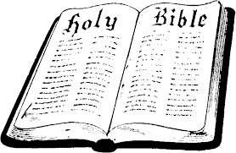
In Class Worksheet
Session 6

John

In Ten Words or Less – Jesus is God Himself, the only Savior of the world.
Know Your Bible, page 66
Portrayal of Christ: GOD HIMSELF, come in the flesh
Target Audience: everyone

Tracing the Deity of Christ: John makes several direct statements about this concept, as well as some statements that infer it. Look at the following verses in John’s gospel and write down the “Jesus is God” statement they contain.

1:1-3 =
1:18 =
5:18 =
8:58 =
9:38 (by inference) =
10:30-33 = (there are two statements in this passage)

14:6-11 = (there are two statements in this passage)

16:15 (by inference) =
17:5 (by inference) =

Other Themes in John’s Gospel: Certainly the “big idea” in John’s gospel is the fact that Jesus Christ is God Himself. But there are several other related themes that you can trace throughout his book as well. You will begin seeing these as you do the marking assignment for this week.

