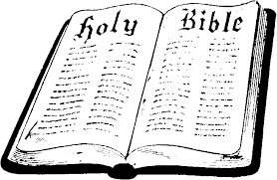
In Class Worksheet
Session 7

John’s Purpose for Writing His Gospel

We saw last week that the “big idea” in John is that Jesus Christ is GOD Himself, come in the flesh to provide salvation for all sinners, both Jew and Gentile. We saw how that concept permeates his entire gospel from beginning to end. It is no surprise then that John also clearly spells out the response he desires from everyone who reads his book: he wants each one to believe in Jesus Christ and receive eternal life through Him.

Tracing the Concept of Believing and Receiving:

1:7 =
1:12 =
3:14-18 = how many times? _______
3:36 =
5:24 =
6:29 =
6:40 =
6:47 =
8:24 =
11:25-26 =
12:36 =
12:46 =
20:30, 31 =

