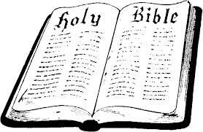
In Class Worksheet
Session 13

2 Corinthians
In Ten Words or Less – Paul defends his ministry to the troubled Corinthian church.
Know Your Bible, page 74

Introduction to 2 Corinthians: ¹Paul, an apostle of Christ Jesus by the will of God, and Timothy our brother, to the church of God that is at Corinth, with all the saints who are in the whole of Achaia: ² Grace to you and peace from God our Father and the Lord Jesus Christ.
³ Blessed be the God and Father of our Lord Jesus Christ, the Father of mercies and God of all comfort, ⁴ who comforts us in all our affliction, so that we may be able to comfort those who are in any affliction, with the comfort with which we ourselves are comforted by God. ⁵ For as we share abundantly in Christ's sufferings, so through Christ we share abundantly in comfort too. ⁶ If we are afflicted, it is for your comfort and salvation; and if we are comforted, it is for your comfort, which you experience when you patiently endure the same sufferings that we suffer. ⁷ Our hope for you is unshaken, for we know that as you share in our sufferings, you will also share in our comfort.
⁸ For we do not want you to be unaware, brothers, of the affliction we experienced in Asia. For we were so utterly burdened beyond our strength that we despaired of life itself. ⁹ Indeed, we felt that we had received the sentence of death. But that was to make us rely not on ourselves but on God who raises the dead. ¹⁰ He delivered us from such a deadly peril, and he will deliver us. On him we have set our hope that he will deliver us again. ¹¹ You also must help us by prayer, so that many will give thanks on our behalf for the blessing granted us through the prayers of many.

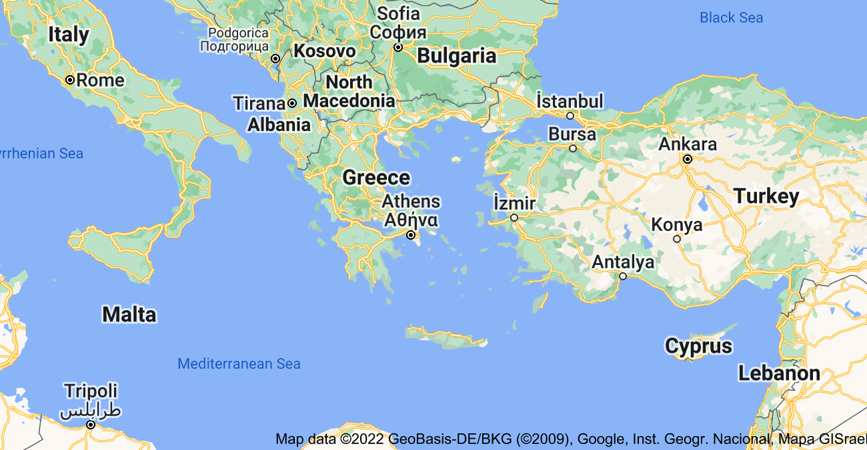
Achaia

Observations from the Introduction and Maps
- MAP: The region of Achaia, indicated in burgundy on the upper map, was located in the modern day country of Greece. Corinth was the capital of the region.

- Note the verb tenses used in 2 Cor. 3-11.

- COMFORT…AFFLICTION…and US

