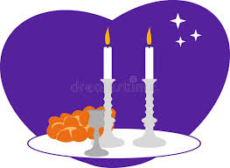
Breathe
Session 2
3-4 April 2023
In Class:
- Go over the yellow “Chiasmus” sheet.
- Read “Sabbath Set Up” on pages 37-39.
- Watch video and discuss it.

Homework (Due 10-11 April 2023)
Breathe Book:
- Read Week 2, pages 42-63.
- Answer the questions that are scattered through the text.

New Testament Survey:
- Read page 87 in Know Your Bible on the book of James.
- Note: The word “gospel” does not occur in this letter at all. But James has plenty to say about faith and religion!

- Printout of James:
- This letter contains a great deal of very practical advice, which we have probably heard quoted many times in our lives. Read the FIRST page and underline any admonition that sounds very familiar to you…using any color pencil you like!

- Now read the second page and do the following exercises:

- Using a PURPLE pencil, draw a circle around the words doer(s) or doing every time they occur in James 1:22-27.

- Using the same PURPLE pencil, underline every occurrence of the word works in James 2:14-26.

- Underline every occurrence of the word faith with a GREEN pencil.

- James mentions two kinds of “good works” on page 2 of the printout. What are they?

James 1:26

James 1:27 with 2:15

- What does James say about people who neglect to do these two things?

That their religion is and their faith is .

