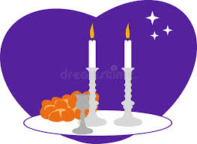
Breathe
Session 3
10-11 April 2023
In Class:
- Read “Sabbath Set Up” on pages 65-67.
- Watch video and discuss it.

Homework (Due 17-18 April 2023)
Breathe Book:
- Read Week 3, pages 70-85.
- Answer the questions that are scattered through the text.

New Testament Survey:
- Read pages 88-89 in Know Your Bible on the books of 1 & 2 Peter.
- 1 Peter — Notice the similarities between 1 Peter and the book of James:
- Who is the target audience (vs 1)?
- What subject do both writers address early in their books?
(Hint: compare James 1:2-4 with 1 Peter 1:6-7.)
- What similar advice do they give? (Compare James 1:2 with 1 Peter 4:12-13.)

- Use a BLUE pencil to circle the phrase good news ( i.e. gospel) wherever it occurs.
- Use a DEEP RED pencil to underline the phrases at the revelation of Jesus Christ, to be revealed in the last time and when his glory is revealed in 1 Peter 1:3-13 and 4:13.

- 2 Peter — Use the same DEEP RED pencil to underline the phrases the day of judgment and destruction of the ungodly, the day of the Lord, the day of God, and the day of eternity. (Hint: there is ONE of these phrases in each paragraph of the 2 Peter passage.)

