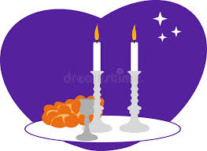
Breathe
Session 4
17-18 April 2023
In Class:
- Read “Sabbath Set Up” on pages 87-89.
- Watch video and discuss it.

Homework (Due 24-25 April 2023)
Breathe Book:
- Read Week 4, pages 92-111.
- Answer the questions that are scattered through the text.

New Testament Survey:
- Read pages 90-92 in Know Your Bible on the books of 1, 2, & 3 John.
- Do the following exercises for PAGE 1 of the printout:
- Use a YELLOW highlighter to highlight the word light wherever it occurs on this page.
- Use a DARK GRAY pencil to draw a slash through the word darkness on the page.
- Use a GREEN pencil to underline phrases containing the word life AND draw a circle around the word.
- Using the same GREEN pencil, draw a circle around the word it in 1 John 1:2.
- Use a BLUE pencil to draw a circle around word wherever it occurs on this page.
- Look for other similarities between the gospel of John and the book of 1 John:
- What word is mentioned in the first phrase of both books?
- What phrase is repeated twice in 1 John 1:1-3 and in the second half of John 1:14?
“…we …”

- Now do the following exercises for PAGE 2 of the printout:

- Use a PURPLE pencil to underline the phrase walking in the truth on page 2. Also draw a circle around every occurrence of the words truth or true.

- Note some similarities between 2 John and 3 John:
- What is similar about the opening phrase of these two letters?

- What is similar about 2 John 1:12 and 3 John 1:13-14?

