Assignment 1
due 18-19 September 2023

You may either work on memorizing the book of 1 Peter OR create your own set of memory verses to help you grow in specific areas of your spiritual life.

- SELECTING VERSES TO WORK ON: If you opt to select your own set of verses, complete the “Schedule for Memorizing My Verses” by writing in references for the verses you choose to work on during the next four weeks.

- MEMORY WORK: Begin memorizing 1 Peter 1:1-2 OR the verse(s) for Week 1 on your personal schedule.

- MEMORY AID #1: Hand Motions – Turn to page 36 in the God of Freedom workbook and practice the hand motions for memorizing the 10 Commandments in order.

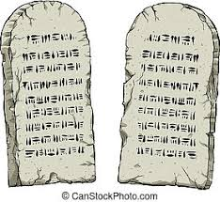

God of Freedom Workbook Done:
- Read the introduction to the workbook, pages 6-11.
- Read Exodus 19:1-25.
- Answer the questions for Days 1-3 of Week 2 on pages 18-23 of the workbook. (You can skip question #2 for now and complete it next week after you read Exodus 20.)

