Assignment 2
due 25-26 September 2023

- YOUR PERSONAL VERSES: Work on the passage you chose for this coming week.
- TEN COMMANDMENTS: Be able to say the short summary of each command and give the correct hand motion. Also be able to tell the characteristic of God associated with each of the FIRST THREE commands.

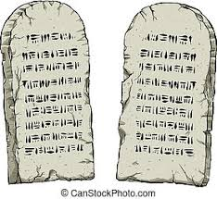

God of Freedom Workbook
Done: .
- ___ Read Exodus 20.
- ___ Answer question 2 for Day 1, on page 18 of the workbook.
- ___ Answer the questions for Days 4-5 of Week 2 on pages 24-28 and do the “Wrap-Up”
at the end.

