Assignment 3
due 2-3 October 2023

Done: .
- ___ Memorize the verse(s) for Week 3 on your schedule.
- ___ Mark the parallels to 1 Peter on the printout of the text with a blue pencil.

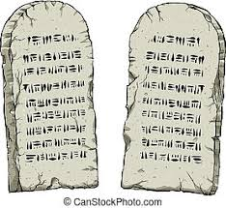

God of Freedom Workbook
Done: .
- ___ Read Exodus 20:1-12.
- ___ Answer the questions for Days 1-3 of Week 3 on pages 35-42.

