Assignment 4
due 9-10 October 2023

Done: .
- ___ Memorize the verse(s) for Week 4 on your personal schedule. Be prepared to recite some of your verses in class.

- ___ Circle the parallels to 1 Peter on the printout of the text with a blue pencil. (See the assignment at the end of the Jen Wilkin lecture notes.)

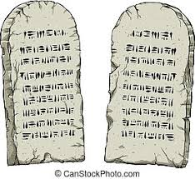

God of Freedom Workbook
Done: .
- ___ Read Exodus 20:1-12.
- ___ Answer the questions for Days 4-5 and do the Wrap-Up for Week 3 on pages 43-46.

