Assignment 7
due 6-7 November 2023

Done: .
- ___ Memorize the verse(s) for Week 7 on your schedule = .

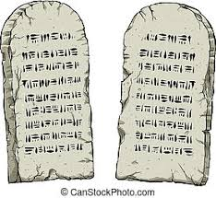

God of Freedom Workbook
Done: .
- ___ Read Exodus 20:22 – 23:9.
- ___ Answer the questions for Days 1-3 for Week 5 on pages 67-73.

