Assignment 10
due 27-28 November 2023

Done: .
- ___ Memorize the verse(s) for Week 11 on your personal schedule = .

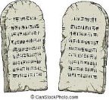

God of Freedom Workbook
Done: .
- ___ Read Exodus 26:1-37 and Exodus 30:1-10.
- ___ Answer the questions for Days 4-5 and do the Wrap-Up for Week 6 on pages 91-95.

