Assignment 11
due 4-5 December 2023

Done: .
- ___ Memorize the verse(s) for Week 11 on your schedule = .

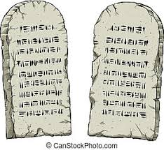

God of Freedom Workbook
Done: .
- ___ Read Exodus 27 and Exodus 30:11-38.
- ___ Answer the questions for Days 1-3 for Week 7 on pages 101-106.

