Assignment 9
due 20-21 November 2023

Done: .
- ___ Memorize the verse(s) for Week 10 on your schedule = .

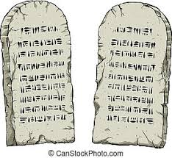

God of Freedom Workbook
Done: .
- ___ Read Exodus 25:1 – 26:40.
- ___ Also read Hebrews 9:1-28.
- ___ Answer the questions for Days 1-3 for Week 6 on pages 83-90.

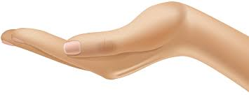
Last week you were asked to pray about how you might be involved in this ministry. People have come up with several suggestions:
And, of course, making a friendship visit!
Be the BLESSing

- Make cards for the ones we visit.
- Make goodies to take to someone.
- Buy a meal to take to someone OR participate in a group cooking session to prepare meals that could easily be frozen.

- Pray for those involved in the ministry, whether or not you yourself can participate at this time.

As the Lord leads you, fill in the form below and return it to me so we can make plans to move forward.

Name: Date:

I would like to participate in “Be the BLESSing” in the following way(s):

