Assignment 12
due 11-12 December 2023

Done: .
- ___ Memorize the verse(s) for Week 12 on your personal schedule = .

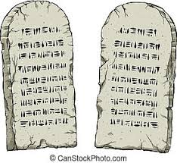

God of Freedom Workbook
Done: .
- ___ Read Exodus 30:17-38.
- ___ Answer the questions for Days 4-5 and do the Wrap-Up for Week 7 on pages 107-109.

