Assignment 13
due 8-9 January 2024

Done: .
- ___ Memorize the verse(s) for Week 13 on your schedule = .
_____________________________________________________________________
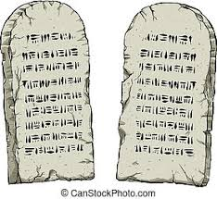

God of Freedom Workbook
Done: .
- ___ Read Exodus 28.
- ___ Answer the questions for Days 1-3 for Week 8 on pages 117-122.

