Assignment 14
due 15-16 January 2024

___ Memorize the verse(s) for Week 14 on your personal schedule = .
_____________________________________________________________________

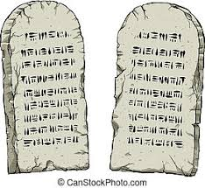

God of Freedom Workbook
Done: .
- ___ Read Exodus, chapters 29 and 31.
- ___ Answer the questions for Days 4-5 and do the Wrap-Up for Week 8 on pages 123-127.

