Assignment 15
due 22-23 January 2024

___ Memorize the verse(s) for this week on your schedule.
___________________________________________________________________
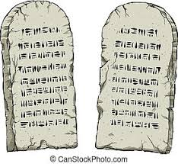

God of Freedom Workbook
Done: .
- ___ Read Exodus 32.
- ___ Answer the questions for Days 1-3 for Week 9 on pages 134-138. (You can skip questions 2 and 3 of Day 1 for now and do them next week when we consider chapters 33 & 34.

