Assignment 17
due 5-6 February 2024

___ Memorize this week’s verse(s) on your schedule.
___________________________________________________________________
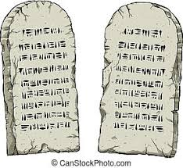

God of Freedom Workbook
Done: .
- ___ Read Exodus 35-40.
- ___ Answer the questions for Days 1-3 for Week 10 on pages 150-155.

