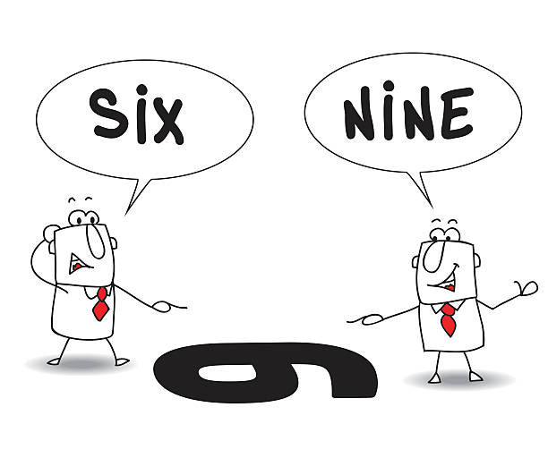

Another Perspective
Session 3
18-19 March 2024

NOTE: We will resume videoing the homework discussions for the benefit of those who have to miss class at some point. I will also put my comments in writing as much as possible, beginning with some things shared last week during the discussion.
Page 22: Rejected…or Unexpected? – Lysa views Jesse’s failure to call David in from the field when Samuel asked to see his sons as a form of rejection. However, in light of the importance of the oldest son in that culture, it seems only natural that Jesse would assume that one of his older sons would be chosen as king…and someone had to watch the sheep! So I don’t think David was rejected by his father, but was an unexpected choice. In either case, God saw to it that the right man was anointed by Samuel.
Pages 22-23, A Harmful Spirit from God – The Crossway Women’s Study Bible has a helpful comment on page 438, regarding the evil spirit mentioned in 1 Samuel 16:14. They said, “A harmful spirit sent by the Lord tormented Saul as a form of judgment for his turning against the Lord (15:22-29). Though God Himself never does evil, He sometimes uses evil agents to accomplish His purposes (such as the Babylonians conquering Israel or sinful people crucifying Christ).”
We see examples of this in various places in the Old Testament. One is found in Jeremiah 25:7-9. God speaks to a rebellious Israel, who has repeatedly “refused to obey or even pay attention” to the warnings of Jeremiah, and says, “Because you have not obeyed My words, I am going to send for…my servant Nebuchadnezzar, king of Babylon…This whole land will become a desolate ruin, and…will serve the king of Babylon for 70 years.”
Page 29, Names of God Used in Psalm 51 – When David pours out his heart to God in deep repentance and contrition, it is interesting to note how he addresses Him. He calls out first to Elohim, his Creator, in verses 1, 10, 14, and 17, and pleads for mercy, cleansing and restoration. In verse 15 David addresses Him as Adonai, designated in English as “Lord” with lower case letters, meaning “master or lord”. In verses 10-12 David pleads with God to not take the Holy Spirit from him but to renew a right spirit within him. What is interesting is the one name David does NOT use: Yahweh or Jehovah, the covenant name showing God’s special relationship with His people (designated in English in all capitals: Lord). Why? Because David has broken the covenant, and now the relationship is broken! David knows that he has no claim upon Yahweh until the relationship is restored.
A similar idea is found in the New Testament when Jesus tells the parable of the Prodigal Son (Luke 15:11-24). When the rebellious son comes to his senses and considers returning home, he rehearses what he will say to express his humble contrition: “Father, I have sinned against heaven and before you. I am no longer worthy to be called your son. Treat me as one of your hired servants.”

