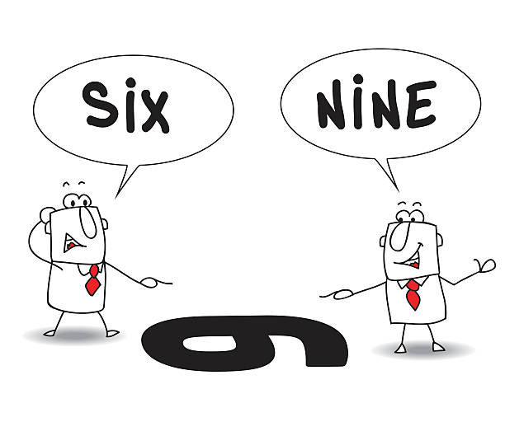

Another Perspective
Session 4
25-26 March 2024

Page 73, “Whatever Captivates Our Heart Fuels Our Actions” – This concise statement explains the downfall of both Solomon and Jeroboam in a nutshell. Solomon’s heart was captivated by women and a strong attachment to the high places, which led him into idolatry. (Note: Solomon’s having 1000 wives/concubines is not about sex as much as it is about an absolute obsession to possess more than you could possibly ever need. It is a form of hoarding. A modern day example is Imelda Marcos, the former First Lady of the Philippines. According to Wikipedia, “After Imelda left Malacañang Palace, press reports worldwide took note of her lavish wardrobe, said to include 15 mink coats, 508 gowns, 888 handbags, and 3,000 pairs of shoes.”) Jeroboam’s heart, on the other hand, was captured by fear, which led to his ruin when he chose idolatrous solutions to his perceived problem. And both men ended their lives categorically refusing to heed God’s warning and persisting in following their own way of worship, thereby falling under God’s wrath and judgment.
Pages 80-85, The Troubling Deaths of a Prophet and a Young Prince – Lysa TerKeurst finds both of these accounts in the life of Jeroboam puzzling and troubling, the first because it seems so “bizarre” and the second because she finds it “too heartbreaking”. She suggests that we reserve judgment on the death of the prophet until we get to Heaven, and that maybe we should just skip over the account of the death of Jeroboam’s son for now. But it seems to me that if we are to “love the Lord our God with all our hearts and all our minds”—and we are—then it behooves us to take a careful look at these things and try to put them in their rightful context. God gives us His Word for our benefit today, not just in Heaven. So we are going to spend the remainder of today’s class taking a careful look at the lives of Solomon and Jeroboam as recorded in 1 Kings 11-14.
Scripture References #1 – As we read through these four chapters, notice how a certain theme is repeated: We see some leader turning away from God’s commands and doing wrong things. Then God pronounces His judgment on that person, telling him exactly what He intends to do . . . and then He proceeds to carry out His plan and purpose, using the natural flow of political events to do so. Everything recorded in these chapters reveals the truth of the sovereignty of our righteous Creator God. They also show how He demonstrates mercy in the midst of judgment, over and over again.
1 Kings 11:1-13 – Here we find Solomon’s sad fall into idolatry and God’s response to that. The Lord tells Solomon exactly what will happen as a result of his disobedience: the kingdom will be “torn away” from him—indicating how unwilling he will be for this to happen—and will be given to one of his “servants”.
1 Kings 11:14-40 – God begins to fulfill what He has said by raising up three adversaries against Solomon: an Edomite, the king of Damascus…and one of his own servants, Jeroboam! And as Jeroboam is going about his duties for King Solomon, he encounters the prophet Ahijah, who tells him exactly what God is going to do. Of course, the king has ears everywhere, and so he learns about what Jeroboam has been told, and he tries to kill him.
1 Kings 11:41-12:24 – Solomon dies, his son Rehoboam takes the throne, Jeroboam hears about the change and comes home from Egypt, and the Israelites ask him to present their request to the new king, which he does. And we have the familiar account of Rehoboam not listening to his elders but following the advice of the young hotheads he had grown up with, which leads to open rebellion against his reign. This all seems like pure politics until we read verse 15: “…for it was a turn of affairs brought about by the Lord that He might fulfill His word…” Rehoboam is determined to regain control of the rebels, and so he sends a man named Adoram—who is Jeroboam’s replacement as head of the forced labor crews—to get men to work for him, but the Israelites stone him to death. More politics: King Rehoboam assembles an army of 180,000 warriors to force the Israelites to submit to him, but God intervenes with a message for the king from one of His prophets, “You shall NOT go up or fight against your relatives the people of Israel. Every man return to his home, for this thing is from Me.” And this time Rehoboam shows some wisdom and heeds what God tells him.
1 Kings 12:25-33 – Here is where we find the sad account of Jeroboam talking to himself…and not telling himself the truth. He tells himself that if the Israelites continue to make the required pilgrimages to Jerusalem, then their hearts will be drawn back to Rehoboam, and he will lose his new kingdom. So his solution to this problem is to establish an entirely new system of worship. Notice the last two verses of this chapter, “And Jeroboam appointed a feast on the fifteenth day of the eighth month like the feast that was in Judah, and he offered sacrifices on the altar. So he did in Bethel, sacrificing to the calves that he made. And he placed in Bethel the priests of the high places that he had made. ³³ He went up to the altar that he had made in Bethel on the fifteenth day in the eighth month, in the month that he had devised from his own heart. And he instituted a feast for the people of Israel and went up to the altar to make offerings.”

Scripture References #2
1 Kings 13:1-10 – Enter the prophet of God, who comes with a prophetic warning for Jeroboam that will be fulfilled many years in the future, when King Josiah of Judah will come to carry out religious reforms throughout the land. But the man of God also gave a sign for that very day, i.e. the day he is confronting Jeroboam, which angers Jeroboam. Jeroboam points to the prophet and tells his men to seize him…but that rebellious hand is “dried up” or withered, and then Jeroboam pleads for mercy. And God shows him mercy by restoring his hand to its normal condition. So now Jeroboam wants to reward the prophet for interceding on his behalf, and he invites him to come to his house for dinner. But the man of God refuses, telling Jeroboam that the Lord had forbidden him to eat or drink in that place. Why? I suspect that it has to do with the significance of sharing a meal. Eating together is a sign of friendship and fellowship, of acceptance. But how could a man of God have fellowship with someone who had completely rejected God’s commands and had gone so far as to set up his own religion? As Paul asked in 2 Corinthians 6:14-16, “What partnership has righteousness with lawlessness? Or what fellowship has light with darkness?...What agreement has the temple of God with idols?” God could not allow His representative to, in effect, set his seal of approval on the wicked things that Jeroboam was doing by eating with him. And since Jeroboam had led his followers into his own path of idolatry, there was no one there with whom he should eat.
1 Kings 13:11-34 – But then the man of God himself makes a fatal mistake: he accepts the word of someone who has the appearance of righteousness and who knows the “right words” to persuade him to disobey what was a very clear command of God. God had said, “Don’t turn back,” but he did turn back to go to the deceiver’s house. God had said, “Don’t eat anything or even drink water in that place,” but he did eat and drink in the deceiver’s house. He apparently made no attempt to check the validity of what the lying prophet told him, and it cost him his life in a very unusual, very public way. A lion attacks and kills him, yet does not eat his body OR attack the donkey he was riding. And the donkey, contrary to all expectation, stays right there beside the lion until someone comes to bury the prophet’s body. Why such a seemingly harsh punishment? Let us recall that the man of God had been sent to Jeroboam precisely because Jeroboam had rejected the Word of the Lord. And now that same prophet of God has treated a command of God carelessly. I think God was using the death of this man and the contrary-to-their-nature behavior of the two animals to communicate the fact that He takes His Word very seriously, and we ignore it to our peril. Think of other examples in Scripture of people who treated God and His Word carelessly and died as a consequence: Nadab and Abihu (Aaron’s sons), followers of Korah in Moses’ day, and Ananias and Sapphira in the New Testament.
But sadly, Jeroboam did not take the message to heart. Instead, he went right back out and made more priests for his high places of idol worship. And that would ultimately lead to the destruction of his entire family.
1 Kings 14:1-18 – And that brings us to the account of the death of Jeroboam’s son Abijah. If I understand Abijah’s name correctly from what I read in Strong’s Concordance, it means “worshipper of Yahweh”. If so, it is beyond ironic that Jeroboam, the ultimate idolator, would choose this name for his son!
As we read this account, remember how we started out: we are looking for examples of someone disobeying God’s commands, of God spelling out judgment on him in detail, and then God carrying out what He said He would do. Jeroboam has persisted in his evil idolatry, and now God is bringing judgment on him. God tells Jeroboam’s wife, “I will bring harm upon the house of Jeroboam and will cut off from Jeroboam every male, both bond and free, and will burn up the house of Jeroboam as a man burns up dung until it is all gone.” And then He said specifically that their son Abijah would die as soon as she returned home; Abijah is a sort of “first fruits” of God’s judgment.
But also notice that God tempered His judgment with mercy. He said that, unlike all the other males in the family, Abijah would have an honorable burial “because in him there is found something pleasing to the Lord, the God of Israel.” And think how he was spared growing up in a totally pagan society that may have turned his heart away from worshiping Yahweh.
If you, like Lysa TerKeurst, are troubled by the fact that a child died because his father had sinned, remember three things:
1) We are ALL children whose death is tied to the disobedience of a parent. 1 Corinthians 15:22 says, “for in Adam all die.”
2) God is sovereign: He is the one who determines how long we live. He is the one who numbers our days. So a seemingly “early” death isn’t a tragedy, it is part of His sovereign will.
3) Death is an enemy that will someday be destroyed, never to cause us sorrow again.

