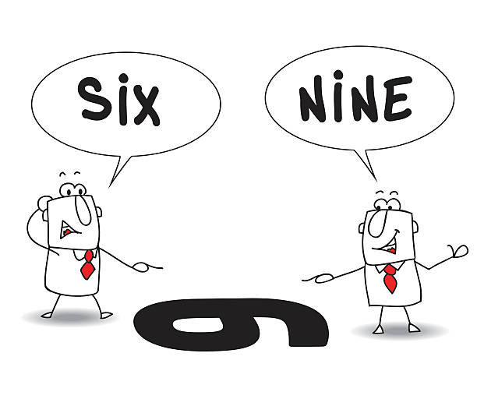

Another Perspective
Session 5
1-2 April 2024

Insights from the Day of Discovery DVD “The Appointed Feasts” – The Feast of Weeks or Pentecost occurs 50 days after Passover. Those seven weeks are crucial ones in the agricultural cycle of Israel. As one of the speakers shared, “Because of the fragile ecosystem of this region, an agricultural drama plays out each year between the LAND of Israel, the PEOPLE of Israel, and the GOD of Israel.” Helen Frenkley, a native of Israel and the Former Director of the Biblical Landscape Reserve, explained, “The most crucial season for the seven varieties of produce (wheat, barley, figs, olives, date honey, grapes and pomegranates) are the two months, April-May, between Passover and Shavuot (Feast of Weeks or Pentecost). During those two months, we have two major phenomena of weather in Israel. The first is called a “hamsin,” which is a hot, dry wind that blows from the east/southeast, raising temperatures in just a few hours by 15°-20°F and lowering humidity to below 15%. Both aspects are terribly important for the pollination of the fruit. This hot, dry weather breaks, so to speak, when the winds shift, coming from the west/northwest and bringing rain. You can imagine the danger if the flower is open, the pollen is exposed, and the rain washes all the pollen off the stamen before pollination can occur. (If that happens, there will be no harvest of olives, figs, grapes, etc. four or five months later.) It's not only that every day of that seven week period is nerve wracking, but every hour of every day the farmers are a nervous wreck. And it’s all in the hands of God. There is nothing we can do about it.”
As I have reflected on what I learned from the teachers on this DVD, I see even more significance in what the Lord promised His people in Leviticus 26:1-5, “Do not make idols for yourselves, set up a carved image or sacred pillar for yourselves, or place a sculpted stone in your land to bow down to it, for I am Yahweh your God. You must keep My Sabbaths and revere My sanctuary; I am the Lord. If you follow My statutes and faithfully observe My commands, I will give you rain at the right time, and the land will yield its produce, and the trees of the field will bear their fruit. Your threshing will continue until grape harvest, and the grape harvest will continue until sowing time; you will have plenty of food to eat and live securely in your land. I will give peace to the land…” So the farmers did not have to be “nervous wrecks”, wondering if the rains would come too soon and wash all the pollen away or come too late for the grain to grow. Because the weather IS in the hands of God—the loving, faithful God who had promised to bless those who obey Him—they could rest assured that He would once again provide a bountiful crop.
But God had also gone on to warn them in Leviticus 26:18-20, “But if…you will not obey Me, I will proceed to discipline you seven times for your sins. I will break down your strong pride. I will make your sky like iron and your land like bronze, and your strength will be used up for nothing. Your land will not yield its produce, and the trees of the land will not bear their fruit.”
It seems that God had deliberately chosen a land for His people that, unlike the Nile delta region in Egypt, was not naturally lush and green all the time, so that they would not take its bounty for granted. Instead He put them in a region where they HAD to depend on Him to send the right weather at exactly the right time each year. It COULD be lush and green and “flow with milk and honey” after the spring rains came, but that depended upon how the people were relating to God and His commands. This whole concept sheds new insight into His purpose for withholding rain for three full years in Elijah and Ahab’s day. That was no arbitrary punishment, but tied directly into what He had been telling His people since the days of Moses: “Obey Me, and I will bless the land. Disobey Me, and I will not allow the land to produce its crops. I am the Lord.” It was an exact fulfillment of Lev. 26:19.

